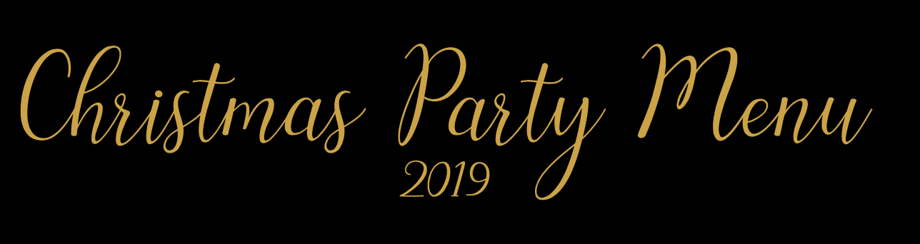

The New Inn, Goodleigh 01271 342488

STARTERS

Hand Pulled Ham Hock & Chive Terrine with Mustard Mayo
Creamy Stilton Mushrooms on Sour Dough Toast
Dill Pancakes Loaded with Smoked Salmon, Sour Cream and Pickled Cucumber
Homemade Chicken Liver & Green Peppercorn Paté
Smokey Tomato Soup Topped a with Salsa of Preserved Lemon & Green Olive

MAINS

Roasted Belly Pork with Sage & Black Pudding Stuffing
Honey Roasted Ham, Leek & Potato Pie
Succulent Roast Turkey Breast with all the Trimmings
Aubergine Parmigiana with Dressed Rocket
Poached Salmon Supreme in a Lightly Spiced Coconut Sauce

PUDDING

Homemade Lemon Posset with Festive Florentine Biscuit
Rhubarb & Ginger Crème Bruleé
Homemade Honeycomb Ice Cream
Christmas Pudding with Boozy Brandy Sauce
Homemade Orange & Cardamon Cheesecake

Coffee & Homemade Mince Pies

£27.95

Pre-booking and ordering required with a £10 non-refundable deposit per person.
Allergen advice available at the time of booking.

